**Assignment 7**

**Question 1**

Given two strings s and t, determine if they are isomorphic.

Two strings s and t are isomorphic if the characters in s can be replaced to get t.

All occurrences of a character must be replaced with another character while preserving the order of characters. No two characters may map to the same character, but a character may map to itself.

**Example 1:**

**Input:** s = "egg", t = "add"

**Output:** true

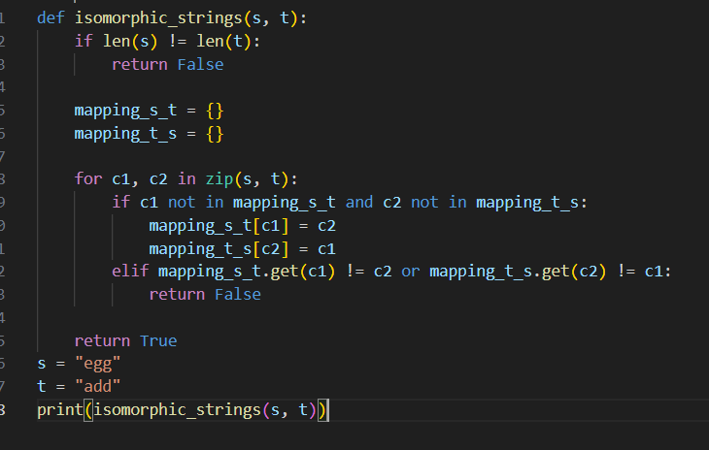

**Question 2**

Given a string num which represents an integer, return true if num is a ***strobogrammatic number***.

A **strobogrammatic number** is a number that looks the same when rotated 180 degrees (looked at upside down).

**Example 1:**

**Input:** num = "69"

**Output:**

true

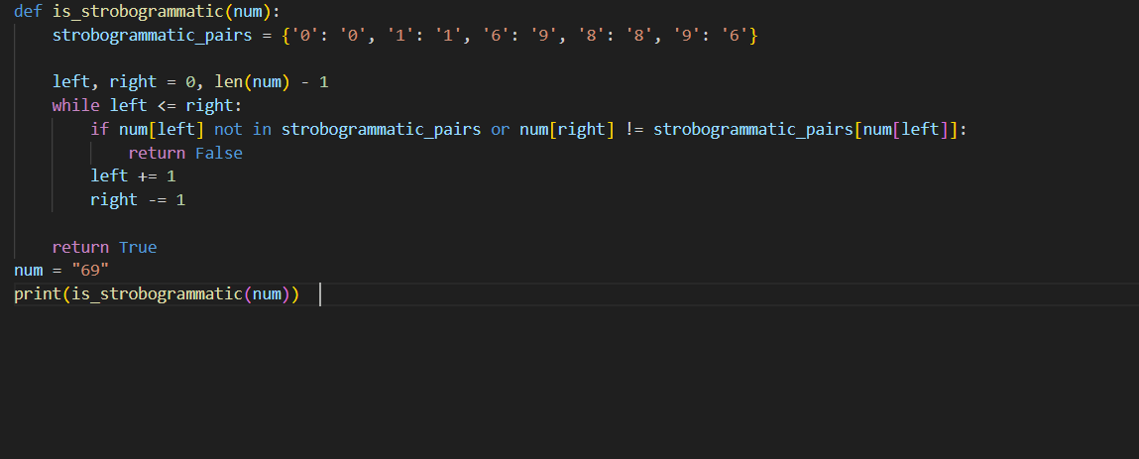

💡 **Question 3**

Given two non-negative integers, num1 and num2 represented as string, return the sum of num1 and num2 as a string.

You must solve the problem without using any built-in library for handling large integers (such as BigInteger). You must also not convert the inputs to integers directly.

**Example 1:**

**Input:** num1 = "11", num2 = "123"

**Output:**

"134"

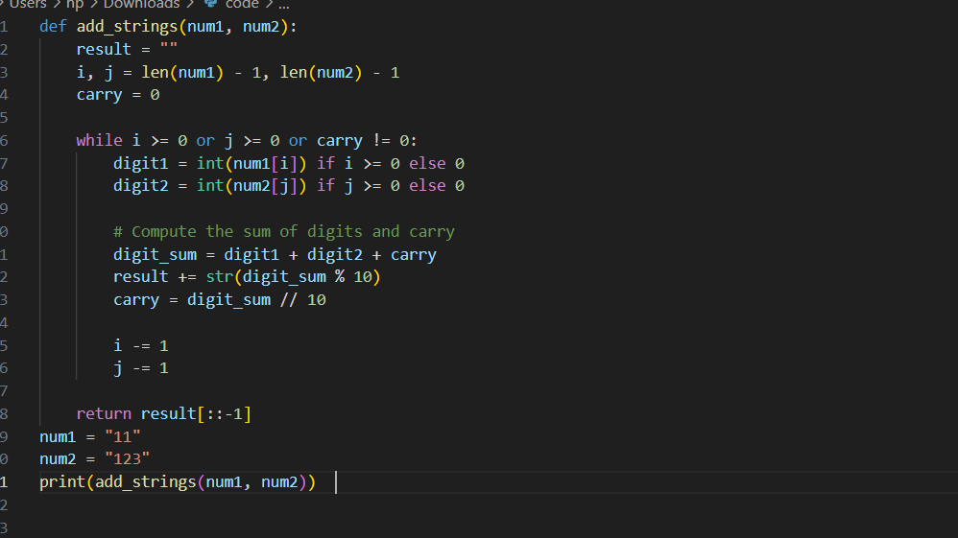

Given a string s, reverse the order of characters in each word within a sentence while still preserving whitespace and initial word order.

**Example 1:**

**Input:** s = "Let's take LeetCode contest"

**Output:** "s'teL ekat edoCteeL tsetnoc"

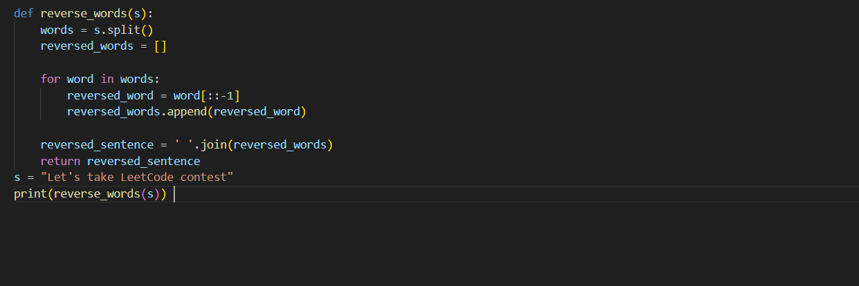

💡 **Question 5**

Given a string s and an integer k, reverse the first k characters for every 2k characters counting from the start of the string.

If there are fewer than k characters left, reverse all of them. If there are less than 2k but greater than or equal to k characters, then reverse the first k characters and leave the other as original.

**Example 1:**

**Input:** s = "abcdefg", k = 2

**Output:**

"bacdfeg"

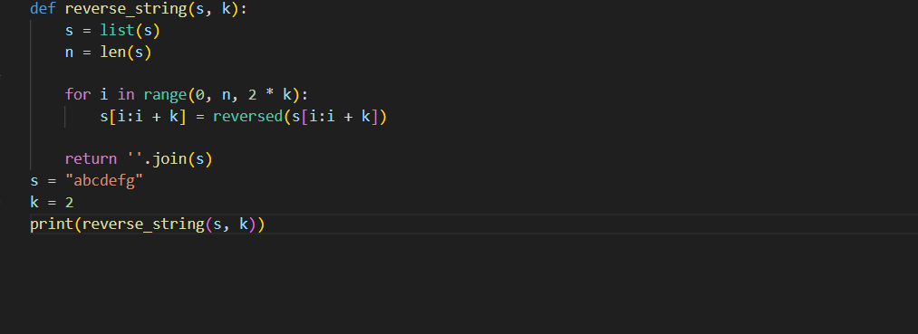

💡 **Question 6**

Given two strings s and goal, return true *if and only if* s *can become* goal *after some number of* ***shifts*** *on* s.

A **shift** on s consists of moving the leftmost character of s to the rightmost position.

* For example, if s = "abcde", then it will be "bcdea" after one shift.

**Example 1:**

**Input:** s = "abcde", goal = "cdeab"

**Output:**

true

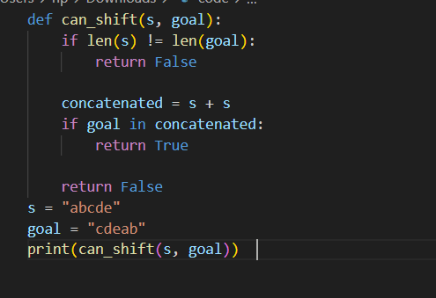

💡 **Question 7**

Given two strings s and t, return true *if they are equal when both are typed into empty text editors*. '#' means a backspace character.

Note that after backspacing an empty text, the text will continue empty.

**Example 1:**

**Input:** s = "ab#c", t = "ad#c"

**Output:** true

**Explanation:**

Both s and t become "ac".

